Set Up Testing Session:

To begin, log into MAP (https://teach.mapnwea.org) and click Manage Test Sessions on the left.

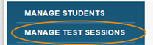

Next, choose Find Students to Test

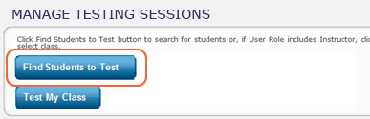
- Click Find Students to Test.
- Choose search criteria and then click Search. This should be all the students in the class chosen.
- Review the search results, deselect students if needed, and click Add Students
- Scroll Down to Student List
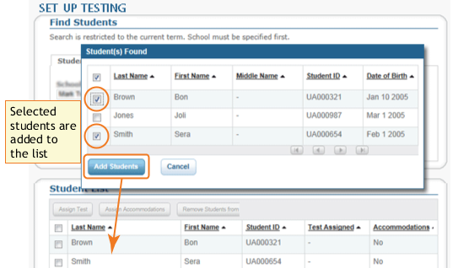

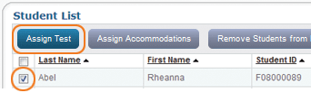
5. Select each student by clicking the check box next to last name and click Assign Test. With their tests assigned, students will have it selected automatically when they sign in.

6. Click Save Session. By saving it, you or someone else can use this testing session at a later time.

