Pendulum Lab Report

Intro:
Question: How does the amount and mass of washers affect a pendulum’s ability to knock over a water bottle? How many washers will it take to knock over a water bottle?

Background Info: A pendulum is a mass tied to the end of a string that has the ability to swing. We chose this question because we wanted to test the power of a pendulum by see if it could knock over a water bottle with a certain amount of mass (in washers) in the end of the pendulum.

Hypothesis: If there is a greater mass/amount of washers then the pendulum will be able to knock over the water bottle more easily because there is more mass and momentum hitting the object. Also, it will take ten washers to knock over the water bottle.

Independent Variable - amount/mass of washers

Dependent Variable - if the water bottle is knocked over

Materials:
- A 305.1 grams aluminum water bottle (some of the weight is water)
- A handful of washers
- 60 cm of fishing line
- A roll of masking tape
- A meter stick
- A desk that is around 60 cm wide and around 70 cm tall

Procedure:

- Build a pendulum using 60 cm of fishing line and tie 3 washers (weighing 20 grams) to the end of the string using a double knot.
- Using masking tape, tape a meter stick to the top right corner of the table and have a little stick out over the right edge of the table. Then, tape the pendulum to the end of the meter stick that is sticking out over the right edge of the table. Place the water bottle 9.5 cm away from the top right leg of the table.
- Next, have the pendulum string even with the bottom right corner of the table and drop it to where it only hits the water bottle once. Do multiple trials adding two more washers each time until the water bottle is knocked over.

Data:

If Water Bottle Is Knocked Over vs. Mass Of Washers (grams)
If Water Bottle Is Knocked Over | Mass of Washers (grams)
No | 20
Yes | 34.7

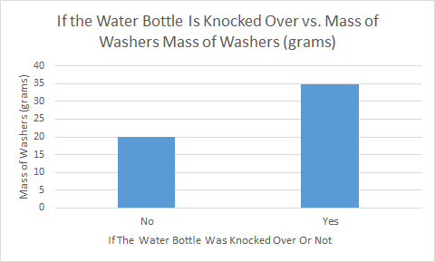

Other Observations:
- When the washers on the pendulum hit the side of the water bottle it wouldn’t fall over, but when it hit from the center or front of the water bottle, it would fall over.

Conclusion: My group’s hypothesis was both correct and incorrect. We were right in saying that a greater mass/amount of washers would knock over the water bottle more easily, but we were wrong with our prediction that it would take ten washers to knock the water bottle over. It only took five. When we only had three washers (20 grams) on the end of the pendulum, the water bottle never fell over, whether we hit it from the front, center, or the side. When we had five washers (34.7 grams) on the end of the pendulum, it fell over when we hit the front and center of the water bottle, but not when we hit the side. On average, five washers (34.7 grams) knocked over the water bottle. This lab visually showed me that when you hit something with more mass and more force, it will knock that something over with more ease. If I wanted to tackle somebody in sports, for instance, I would know that if I hit them with more mass or force, the tackle would have a better chance at being successful. A error we had in our experiment was that we didn’t have an experimental control on where the pendulum hit the water bottle. When the pendulum hit the side of the water bottle it didn’t knock it over, but when it hit the front or center of the water it knocked it over. These observations changed our data, and if we put an experimental control there, our data would have been different.

