Acid and Base Note Guide

The ________ scale measures how acidic or basic something is.

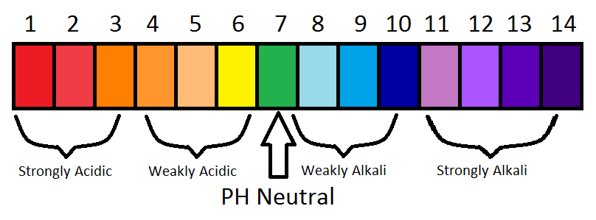
An acid has more _______________ ions.
A base has more ________________ ions.
Something neutral, like water, has a pH of _______ . That means it has equal numbers of H+ ions and OH- ions!
(H+) + (OH-) = _________

The pH scale is logarithmic. That means it increases by factors of ________ .
Tomato juice (pH 4) is __________ times more acidic than water (pH 7).
Bleach (pH 12) is ___________ times more basic than water (pH 7).

_______________ are weak acids or bases that help keep pH within a narrow range.
Buffers help to keep our blood at a pH of __________ .

