2.2 Note-Taking Guide: Properties of Water (Keep me in your student folder please)

- Cool Stats
  - The first _________________ evolved in water!
  - All living things are about ______________ % water!

- Water has two special properties caused by ________________ bonding
  - Cohesion
  - Adhesion

Hydrogen Bonding: The hydrogen in H₂O has a slightly positive charge and likes to stick to other stuff that’s slightly negative like the oxygen in H₂O. This creates a weak attraction like when two weak magnets are held near each other.
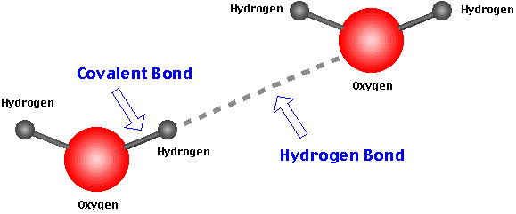
- Cohesion – Water sticks to ____________________.
  - This gives water a high surface tension, meaning that really light stuff like bugs can walk on water when they spread out their weight.
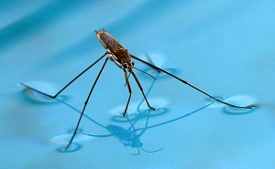
- Adhesion – Water sticks to ____________________ stuff.
  - This allows plants to take up water from their roots in a process called capillary action
