How to Grow a Planet

Episode 1: Life From Light
- Son Doong cave in Vietnam is the world’s largest cave passage, and has a portion where the roof has collapsed. What kind of ecosystem is found there, and why?

The Great Oxidation Event

- List two major ways the Earth’s atmosphere was different 3 billion years ago, before the advent of photosynthesis.

- Iron is normally shiny and grey. What color was the iron taken from the deep rock layer at the mine? Why was it this color?

- The documentary suggests that the oceans on Earth 3 billion years ago may have been purple. Why?

- Cyanobacteria, the ancestors of plants, are green. Why?

  - What do cyanobacteria produce as a waste product?

The Joseph Priestly Experiment, Human-Sized

- What percent oxygen was the atmosphere in the sealed chamber when the experiment began?

- What were two recorded symptoms of oxygen deprivation experienced by Dr. Ian Stewart?

- As the lights were turned on, photosynthesis began in what organelle in the plant cells?

  - How large are these organelles?

  - Photons of light are captured by a _________ ___________ _____________.

  - Water is split into what elements?

- Describe how the oxygen concentration changed over the course of the experiment.

- How did the addition of oxygen change the upper atmosphere of the Earth?

The Move to Land

- The Scottish rocks shown are unique because of the dark splotches and lines throughout. What are these?

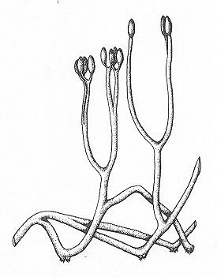

- The earliest land plants are believed to have looked like this. What are they called?

- What additional structure did plants have to evolve before they could move away from the shore?

  - Describe how these structures help to produce soil. How long does this take?

- Horseshoe crabs are studied as “living fossils” because they are similar to the first land animals. What do they have that allows them to go on land?

- What is the main reason why plants photosynthesize – what are they producing?

  - What are the three ingredients or reactants of photosynthesis?

  - What happens to this product once it is made?
- As plants populated the land, carbon dioxide levels plummeted. What special structures did ferns evolve to overcome this?

  - What was the additional benefit of this adaptation?

Carboniferous Period and the Dinosaurs

- How was the concentration of oxygen during this time period compared to today?

- Insects are size-limited by oxygen in the atmosphere. How do they breathe?

  - How long were carboniferous millipedes?

  - What is the wingspan of a carboniferous dragonfly?

- When the dinosaurs evolved, were most of them herbivores or carnivores?

- The largest herbivores were the ____________________.

  - How tall were they?

  - How much do they eat, compared to modern elephants?

- Cycads are plants that evolved defenses against large herbivores like dinosaurs. Give an example of a physical and chemical defense.

- How and when do plants communicate with each other?

- When plants evolved wood, they were able to grow _____________.

- Angiosperms are the last group of plants to evolve. What unique adaptation do they have?

