Anatomy Semester 2 Final Exam Study Guide
- Chapter 6: The Muscular System
  - Objectives
    - Differentiate between the three types of muscular tissue (skeletal, smooth, cardiac) (see p. 163)
    - Label the layers of the muscular tissue that make up a skeletal muscle (epimysium, perimysium, endomysium, fascicle)
    - Label the parts of a muscle cell (sarcolemma, sarcoplasm, sarcoplasmic reticulum, myofibrils,
    - Identify the composition and function of myofibrils (actin and myosin myofilaments forming dark and light bands)
    - Label the components of the neuromuscular junction (motor end plate, synaptic cleft, synaptic vesicles, neurotransmitters)
    - Identify the action of the neurotransmitter acetylcholine.
    - Describe the sliding filament theory in muscle movement using the following terms (ATP, calcium, myosin, actin, acetylcholine, cholinesterase)
    - Describe the process of cellular respiration and how it produces ATP. Predict the effect of creatine phosphate on ATP regeneration
    - Summarize and differentiate between the following muscular disorders: rigor mortis, tetanus, myotonia, and muscular dystrophy.
Gross Anatomy Muscle List
- Head Muscles
  - Orbicularis Oris
  - Epicranius Occipitalis
  - Platysma
  - Epicranius Frontalis
  - Zygomaticus
- Neck Muscles
  - Semispinalis Capitis
  - Splenius Capitis
- Thoracic Muscles
  - Deltoid
  - External Oblique
  - Pectoralis Major
  - Rectus Abdominus
  - Pectoralis Minor
- Shoulder and Back Muscles
  - Trapezius
  - Deltoid
  - Latissimus Dorsi
  - Rhomboideus Major
  - Infraspinatus
- Front Leg Muscles
  - Rectus Femoris
  - Vastus Medialis
  - Vastus Lateralis
  - Sartorius
  - Gracilis
- Back Leg Muscles
  - Gluteus Maximus
  - Gastrocnemius
  - Gluteus Medius
  - Biceps Femoris
  - Semitendinosis
- Top Arm Muscles
  - Triceps Brachii
  - Extensor Carpi Radialis Longus
  - Extensor Carpi Ulnaris
  - Extensor Digitorum
- Bottom Arm Muscles
  - Biceps Brachii
  - Brachioradialis
  - Flexor Carpi Radialis

  - Helpful Diagrams
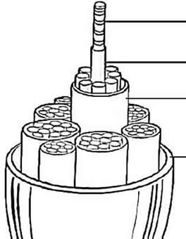

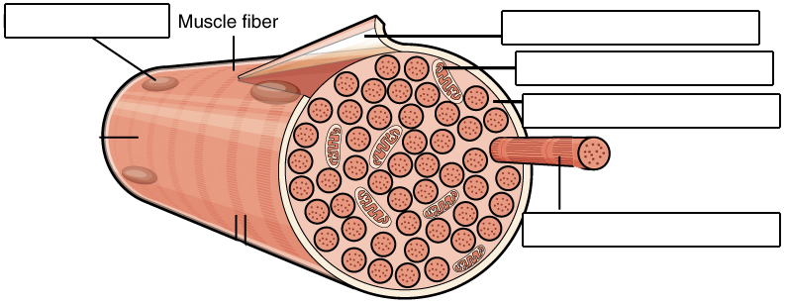
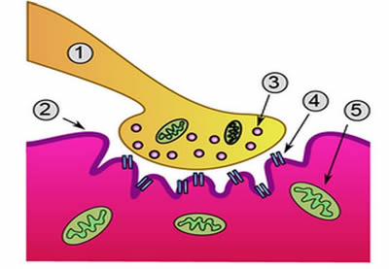
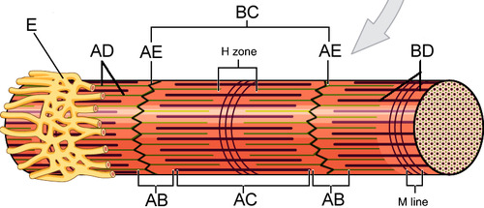
- Chapter 7: The Nervous System
  - Objectives
    - Label the parts of a neuron and identify their functions
    - Differentiate between CNS and PNS
    - Summarize the three basic functions of the nervous system
    - Differentiate between the somatic and autonomic divisions and sympathetic and parasympathetic divisions of the nervous system.
    - Summarize the functions of neuroglia cells and identify them on a diagram.
    - Discuss the factors that affect the speed of a nerve impulse
    - Label and discuss the steps in a reflex arc.
    - Label the internal and external parts of the brain and summarize their functions.
    - Identify the major brain regions on a sheep brain.

  - Helpful Diagrams
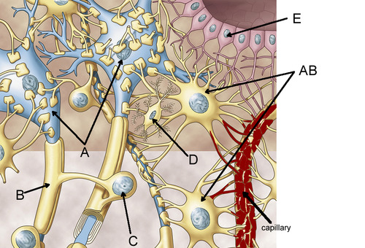
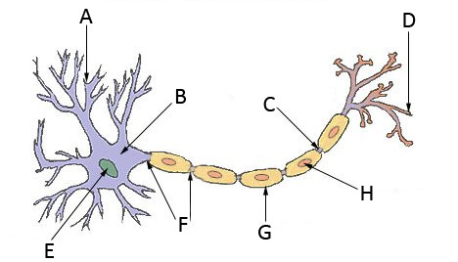
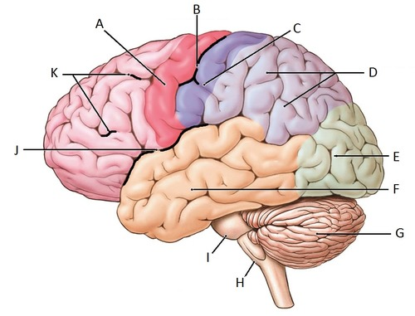
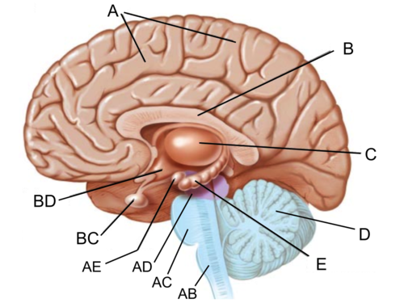
- Chapter 10: Blood
  - Objectives
    - Identify what defines specific blood types in terms of antigens and antibodies.
    - Identify the universal blood donor and explain why it is in terms of antigens and antibodies.
    - Identify the universal blood receiver and explain why it is in terms of antigens and antibodies.
    - Perform Punnett squares to predict the probability of blood type of offspring.
    - Identify the possible genotypes of different blood type phenotypes.
    - Interpret blood typing test results.
    - Determine what blood types can be transfused in a patient with a given blood type.
    - Discuss Rh factor, how it is passed down, and how it can affect a pregnant woman and her fetus in embryoblastosis fetalis.

  - Helpful Diagrams
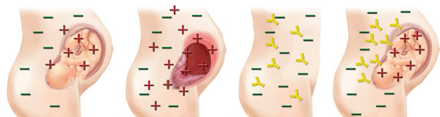

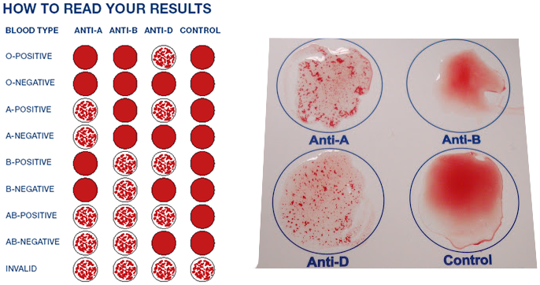

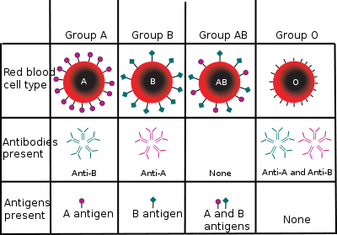

- Chapter 11: The Cardiovascular System
  - Objectives
    - Differentiate between pulmonary and systemic circulation
    - Differentiate between arteries and veins
    - Identify the layers of the heart (epicardium, myocardium, endocardium)
    - Label the heart valves and determine their function (aortic, tricuspid, bispid, pulmonary valves)
    - Draw the pathway of oxygenated blood and deoxygenated blood through the heart.
    - Label the internal structures of the heart. (left atrium, right atrium, superior vena cava, inferior vena cava, right ventricle, left ventricle, aorta, pulmonary arteries, pulmonary veins, papillary muscles, chordea tendinea, septum)
    - Label the external structures of the heart (aorta, apex, pulmonary arteries, pulmonary veins, superior vena cava, inferior vena cava)
    - Interpret ECGs (tachycardia, normal, brachycardia, arrhythmia) and identify normal and abnormal blood pressure (hypertension, hypotension) readings and heart rate
    - Read and interpret blood pressure measurements and discuss factors that affect blood pressure
    - Discuss and differentiate between common cardiac disorders (mvp, heart murmurs, myocardial infraction, atherosclerosis, hypertension, stenosis, and septal defects)

  - Helpful Diagrams
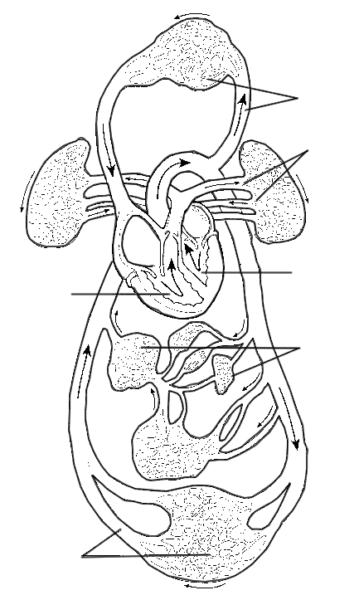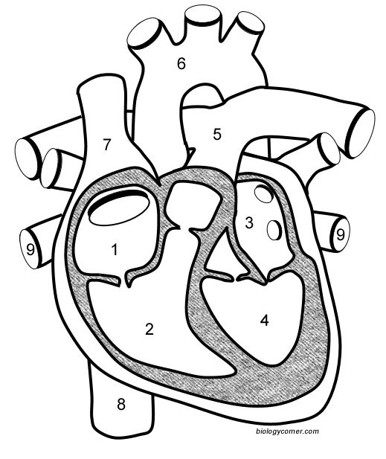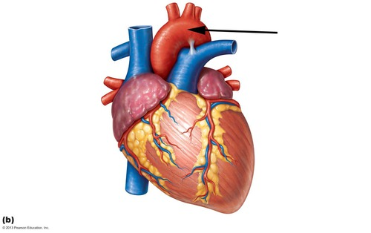
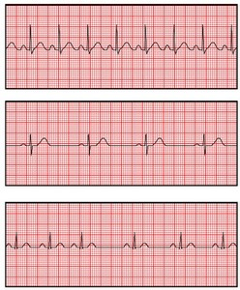
- Chapter 13: The Respiratory System
  - Objectives
    - List the four primary functions of the respiratory system.
    - Describe the process of respiration (external - blood and air), (internal– blood and body cells), (cellular – mitochondria)
    - Label and describe the functions of the structures of the respiratory system (nose, nasal cavity, nasal sinus, nasal concha, mucous membrane, sinuses-maxillary, frontal, ethmoid, sphenoid), pharynx-nasopharynx, oropharynx, laryngopharynx, larynx-glottis, epiglottis, vocal cords, trachea, bronchial tubes-primary, secondary, tertiary, bronchioles, lungs-alveoli)
    - Discuss the role of surfactant in breathing and maintaining surface tension in alveoli
    - Differentiate between resting tidal volume and vital capacity
    - Identify the area of the brain responsible for respiratory actions.
    - Describe the action of the diaphragm on breathing and air pressure in the lungs.
    - Describe and differentiate between respiratory disorders such as cystic fibrosis, COPD, bronchitis, emphysema, sleep apnea, lung cancer, altitude sickness, and asthma.
    - Describe the structure and function of lungs, including lobes, alveoli, cardiac notch, and membranes.

  - Helpful Diagrams
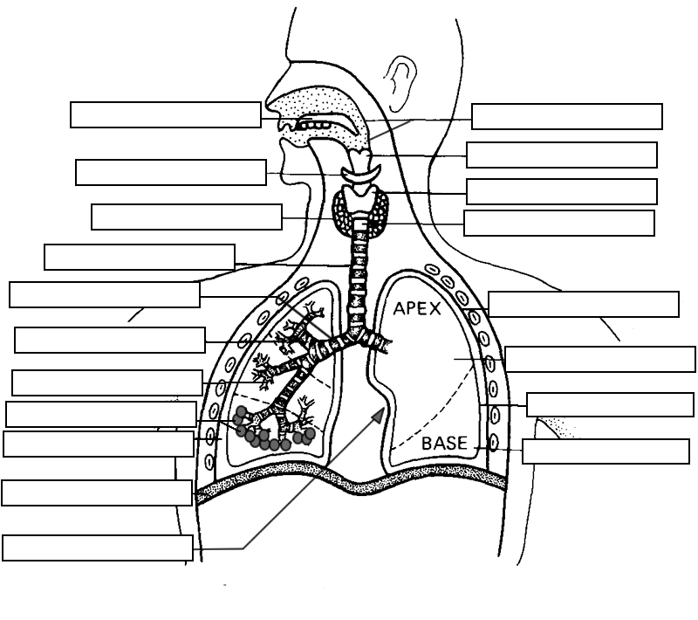
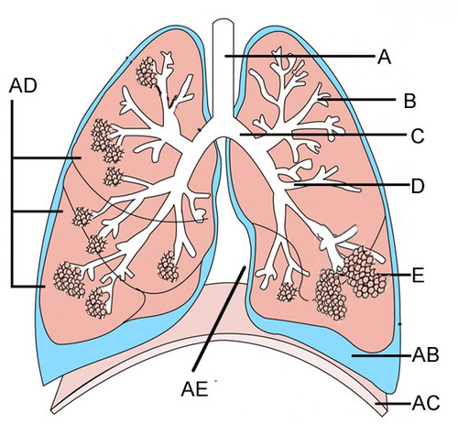
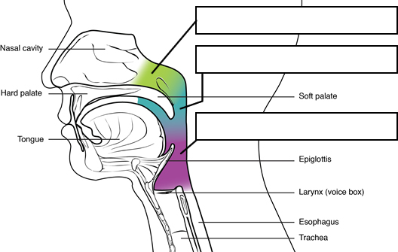

- Chapter 14: The Digestive System
  - Objectives
    - Name the organs of the digestive system and state their primary function(s) and activities. (mouth-tongue, frenulum, palate, uvula; pharynx - nasopharynx, oropharynx, laryngopharynx; esophagus - esophagial hiatus, cardiac sphincter, stomach – lesser curvature, pyloric sphincter, duodenum, rugae, greater curvature, body of stomach, oblique muscles, longitudinal muscles, circular muscles, fundus, chyme; pancreas; biliary system – liver, gallbladder, ducts; small intestine – duodenum, jejunum, ileum, mesentery, greater omentum, villi; large intestine – cecum, colon (ascending, descending, transverse, sigmoid), rectum, anus
    - Identify the overall function of the digestive system as digestion and absorption of foodstuffs.
    - Explain how the structure of villi aid in their function with regards to digestive processes in the small intestine.
    - Label the sections of the alimentary canal (mucosa, submucosa, muscular layer, and serosa) and describe the function of each.
    - Describe the two movements of the alimentary canal (mixing and peristalsis) and what portion of the nervous system controls these movements.
    - Label a tooth diagram (crown, root, enamel, dentin, pulp, bone, root canal, nerves, and blood vessels) and name the main categories of secondary teeth (incisors, cuspids, bicuspids, and molars)
    - Describe the composition (amylase) and function of saliva, mucous, and digestive enzymes (pepsin)
    - Label the salivary glands on a diagram (parotid, submandibular, sublingual)

  - Helpful Diagrams
