Gas Law Graphs Practice Names:
For the following graphs identify the relationship (how to they affect each other) between the two variables (pressure, volume or temperature) and then guess which gas law it represents?

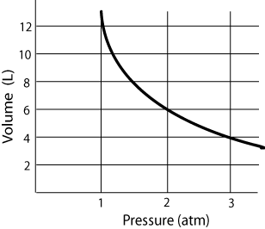
- Relationship:

Gas Law:

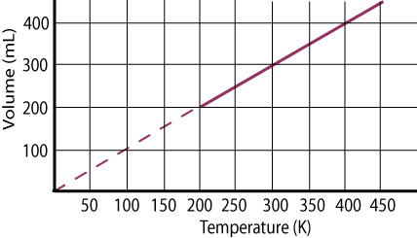
- Relationship:

Gas Law:

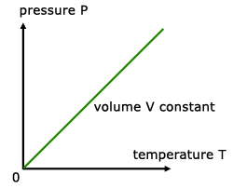
Relationship:

